LED lifting football lamp

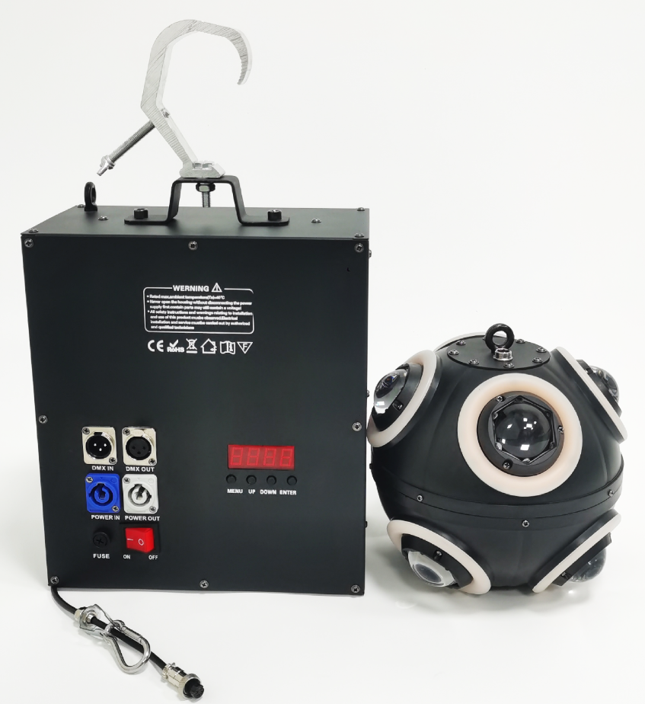

User Manual
(Please read the manual carefully before using the product and properly manage it)

Thank you for choosing to use our LED lifting football lamp. In order to use this product correctly and safely, please read the manual carefully before installing and using this product. This manual contains important installation and application information. Please strictly follow the operation steps when installing and operating the product. At the same time, please keep this manual properly.
Our lift football lamp uses a new beautiful high temperature resistant metal body.This product is designed and produced in strict accordance with the IOS9001 standard. It conforms to the DMX512 signal protocol of the international standard. It can be controlled independently or used online. It has powerful functions and is suitable for small and medium-sized concerts, theaters, studios, nightclubs, bars and other places.

Please carefully remove the package. After the package is removed, check whether the product is damaged during transportation, and check whether the following contents are complete.
Elevator: 1 set
Football lamp -------- 1 set
Instructions: 1
1 power cord
1 signal line
Light hook --------- one
One safety rope
This product is intact before delivery.In order to keep the product in good condition and ensure safe operation, users should follow the safety precautions and warnings in this manual.
Important: Damage caused by not following this manual is not covered by the warranty.The supplier shall not be responsible for the product problems caused thereby.
If the product has ever been exposed to extreme unstable temperature environment (such as after transportation), please do not connect the power supply of the product immediately, because the water droplets generated due to temperature changes may damage the product.Please use it after the product returns to normal temperature.
This product can be used in the voltage range of 100-240V. It is used indoors.Please ensure that the ground voltage used is not higher than the range that the product can bear!!The power plug must be plugged into a Class I socket with good protection.The green or teal conductor must be grounded

DMX512 signal connection
This lamp uses DMX512 signal control mode, and the control signals of each lamp are in parallel relationship. When connecting multiple lamp signals, it is better to use a double core shielded cable. When connecting, each lamp is connected through the DMX signal jack (XLR seat) INPUT and OUTPUT on the lamp. The three core XLR plug terminals of the signal line connecting the lamp must correspond to each other. When connecting the lamp signal,It is recommended to use DMX signal amplifier to avoid damaging control signal due to electric noise.
Calculation method of lamp starting address code:
The starting address code of the current lamp is equal to (the starting address code of the previous lamp)+(the number of channels of the lamp) Description:
1: The starting address code value of the first lamp A001
2: The number of basic channels of the controller shall be greater than or equal to the total number of channels used by the lamp
3: Note: When using any controller, each lamp must have its own starting address code. If the starting address code of the first lamp is set as A001, the number of channels of the lamp is 10CH;Then the starting address code of the second lamp is set to A011;The starting address code of the third lamp is set to A021;By analogy, (this setting mode also needs to be determined according to different consoles).

Installation instructions of lamps:
This lamp only supports hanging. When hanging, pay attention to the installation method (do not tilt). Fixed installation of the lamp: before positioning the lamp, ensure the stability of the installation site. When hanging installation, ensure that the lamp does not fall off the support, and use safety ropes to wear the support and lamp handle for auxiliary hanging;To ensure safety and prevent lamps from falling and sliding. During installation and commissioning of lamps, pedestrians are not allowed to pass below. Regularly check whether the safety rope is worn and whether the hook screw is loose. The manufacturer will not bear any responsibility for all consequences caused by lamps falling due to unstable hanging installation

● Menu description
Change the channel value.Press OK again to save the modified values and exit editing. Press Exit to exit editing without saving the modified values.

- Schematic part:
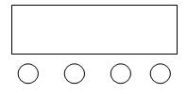
A. Function keys
B. Keying
C. Minus key
D. Confirm key
E. LED display window
A B C D
Operating instructions: Press function key A to cycle the menu function effect. The first two digits of the nixie tube represent the current function (refer to the menu).The last two digits represent the address code, or the speed, parameter of the function.Press B or C to modify the parameter value.Press D to confirm.

LED display window function comparison table (press to select all functions and then press D to confirm)
S/N | display | Function description
1 | Addr | Address code, (001-512)  B. C key plus or minus address code value
2 | Shou | Operation mode selection
3 | Chnd | 10CH
4 | LED | ON,OFF;LED no operation automatic on/off selection
5 | Disp | YES, NO reverse display
6 | Uer | Version No
7 | FAET | YES, NO Restore factory settings

- DMX512 10 Channel Description
S/N | function | explain
Channel 1 | Lifting | 0-255
Channel 2 | Lifting speed | 0-255
Channel 3 | Total dimming | 0-255
Channel 4 | Stroboscopic | 0-10， 11-255
Channel 5 | gules | 0-255
Channel 6 | green | 0-255
Channel 7 | blue | 0-255
Channel 8 | white | 0-255
Channel 9 | Gold | 0-255
Channel 10 | reset | 0-240 invalid, 241-255 delayed for 3 seconds to reset

Technical parameters:
Voltage: AC100~240V 50/60HZ
Power: 150W
Lifting stroke: 6m
Maximum load: ≤ 2.5KG
Speed: ≤ 0.6m/s
Anti falling mode: physical braking, electronic protection.
Lamp beads: 8 15w four in one lamp beads, 8 15w gold light lamp beads
Control mode: DMX512, self-propelled, master-slave.
Channel: 10CH
Dimming: 0~100% linear dimming
Working temperature: indoor - 20 ℃~50 ℃
Strobe frequency: 1~30HZ
Appearance: metal, flame retardant plastic black
Connection mode: DMX512 input/output/power input/output.
IP grade: IP20
Lift size: 26 * 13 * 29cm Lift weight: 7.5KG Ball size: 20CM Ball weight: 1.2KG

